1. Filter output at stop band frequency=350Hz :Amplitude is attenuated

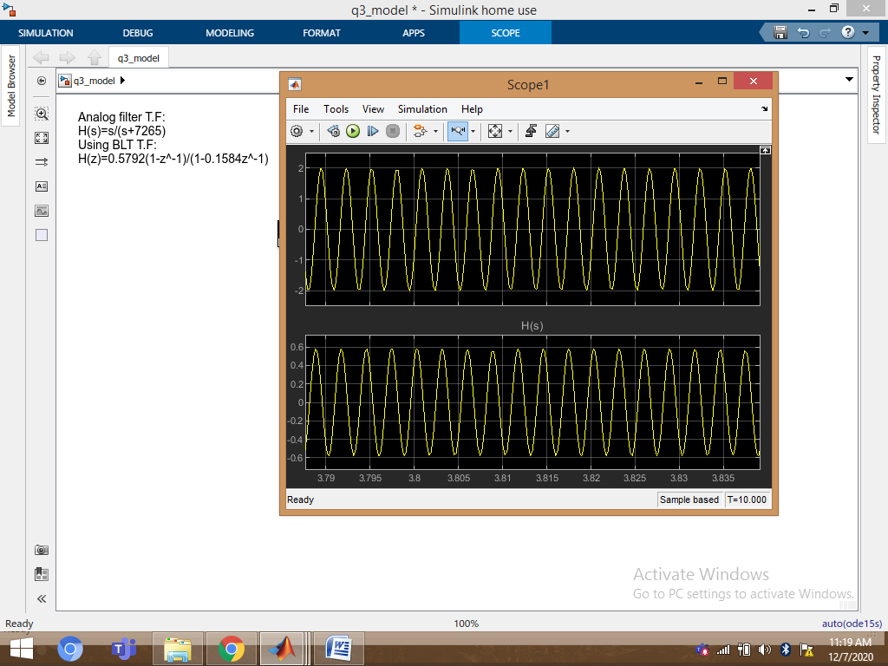

2. Filter output at cutoff frequency=1000Hz :small attenuation of amplitude

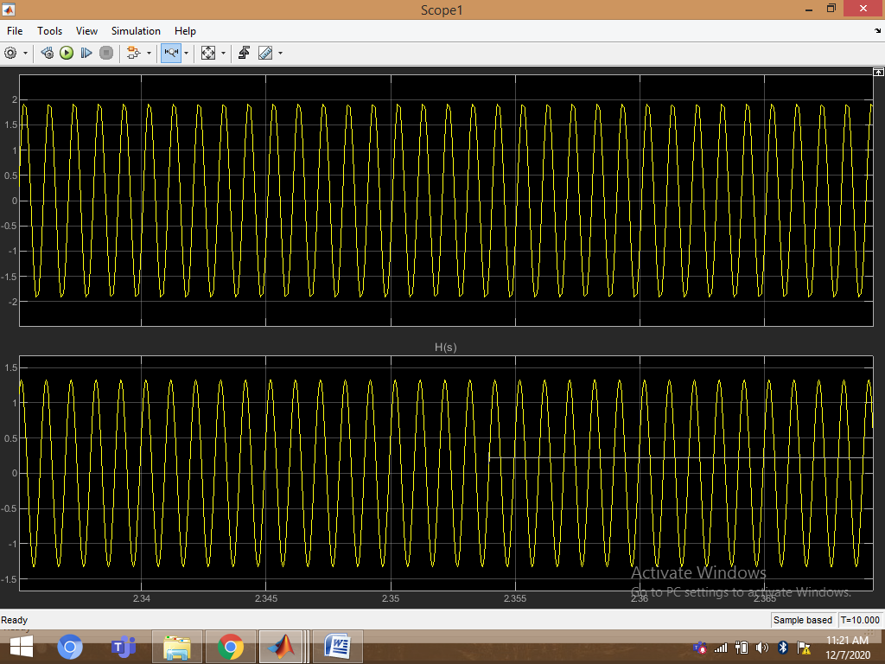

3. Filter output at cutoff frequency=3000Hz :

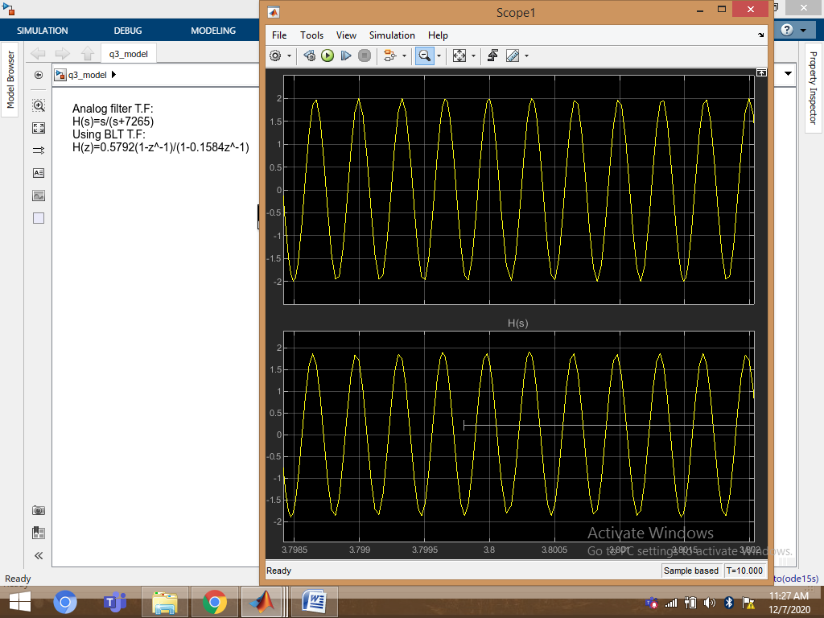

4. Filter output at cutoff frequency=5000Hz :

